|  |  |  |
| --- | --- | --- |
|  |  |  |
| University of Massachusetts Boston  Functional Specification - Search | | |

## Document Version Control

|  |  |  |  |
| --- | --- | --- | --- |
| Version | Author | Date | Changes |
| 1.0 | Craig Taylor [T4] | March 31, 2023 | Document Created |
| **2.0** | Michael Morley [t4] | June 12, 2023 | Version 2 |
| **2.5** | Brittany Terpstra [UMB] | June 13, 2023 | Version 2 Feedback |
| **3.0** | Michael Morley | June 14, 2023 | Version 3 |

## Table of Contents

Document Version Control 1

Table of Contents 2

Introduction 3

Project Goals 3

Scope 3

Out of Scope 4

Technical Architecture 4

Robot Agent 4

HTML Validation & Accessibility 5

Coding Standards 5

Browser & Platform Compatibility 5

Search Page Layout 5

Search Bar 7

Page types 9

Index Schedule 9

Website 9

Programs 12

Directory 14

News 15

Events 17

Promoted Results 19

Promoted Results External 19

Promoted Results Internal 20

Go-Live 20

Document Sign off 21

## Introduction

Terminalfour will be configuring Terminalfour Search to index and search UMass Boston – umb.edu. Terminalfour Search will be implemented using the Tier 2 Package. This solution is a pre-configured search solution providing a set of common university search features.

**Note:** The site(s) which are being indexed need to be publicly accessible and contain content to be indexed.

### Project Goals

The main goal for this project is provide a more comprehensive search for the umb.edu website, utilizing the enhanced functionality of the Terminalfour Search.

## Scope

The scope for the implementation of Terminalfour Search is:

Indexing and search UMass Boston website using a variety of sources (XML and web), depending on the type of content.

The site implementation includes up to 3 filters/facets and one index of the site. The index will be broken down into different areas and used as one of the facets.

Wrap search results in website header and footer

Style search results to match website design

Create a search results page

Updating the website to link the search box to the Terminalfour Search search.

Auto-complete.

Different search results templates for different collections (all search results are in one format for the Tier 2 package)

### Out of Scope

The following items are not within scope for this project:

Indexing Pages which are password restricted

Personalization of search results (all users see the same search results)

## Technical Architecture

The architecture is as follows:

Search term queries the search API and returns the search result to the webserver.

**Terminalfour Search API Server  
(search.umb.edu)**

User clicks on a search result

**Webserver (umb.edu)**

When a user performs a search, they will be taken from the web environment

Index site on a schedule

**NOTE:** When a user performs a search, the search code will query the search api and display the result on the UMass Boston web environment ([www.umb.edu](http://www.umb.edu)) Clicking on a search result (or a link within the results page header/footer) will navigate the user to the page.

### Robot Agent

Terminalfour will modify the robot file to allow Terminalfour Search to index the site.

## HTML Validation & Accessibility

### Coding Standards

Accessibility validation by Terminalfour will be performed using: <https://wave.webaim.org>.

### Browser & Platform Compatibility

Cross-browser testing included the latest versions of the following environments:

Windows operating systems via a laptop: EDGE And Chrome.

Mac OSX operating system via a laptop: Firefox, Chrome, and Safari.

Android via a Samsung Galaxy: Android Browser and Chrome.

iOS via iPhone 11, 12, and 6th generation iPad: Safari and Chrome.

Browser Testing will be carried out using Browser Stack (<http://www.browserstack.com/>).

## Search Page Layout

The following features will be enabled by Terminalfour:

Related search

Number of results per page (this will be set at 10 results per page by default)

Promoted Results

Auto-complete & auto-suggesting results

Sort relevance

The following features will not be used or displayed:

Advanced Search

The website search results page will appear similar to the following:



(1) The header is managed through the CMS, using the Page Layout applied to the search page. Updates to this page will automatically reflect on the search results page.

(2) The facets/filters will be:

* Type: displays the different types of collections the user can filter – Website, Directory, Programs, News & Events
* .

(3) Displays the number results found.

(4) Search results displayed. All results will be linked (it is not possible to have results that do not link).

(5) Related searches based on the keywords entered.

(6) Pagination of search results. By default, there are 10 results per page, but the user performing the search can change this.

(7) The footer is managed through the CMS, using the Page Layout applied to the search page. Updates to this page will automatically reflect on the search results page.

### Search Bar

Terminalfour will update the search bar within the header in the page layouts passing the query entered to the search page:   


Developer Notes:

The code for the search bar is located at Home > Site Assets > Common Header > Search Bar

## Page types

We will be running an index on your site for general webpages, there won’t be a page type applied to these and they will be categorized as General pages. Each other category will have a page type applied to it which will allow you to refine your results based on that.

### Index Schedule

All indexes will be scheduled to update on a daily basis.

### Website

Main university website crawl: <https://umbedu-lb01-production.terminalfour.net/> (on go-live it will be <https://www.umb.edu/>)

#### Content Indexing

This identifies the main part of the page which is indexed. This is done to make sure that navigation, header and footer aren’t included in the search.

Main content Block:

.main-content .wrapper **Exclude** . c-menu-sidebar

#### Meta Data

Title Tag

URL

Description / Content

Page Type: blank

#### Results Format

Results will be formatted similar to:

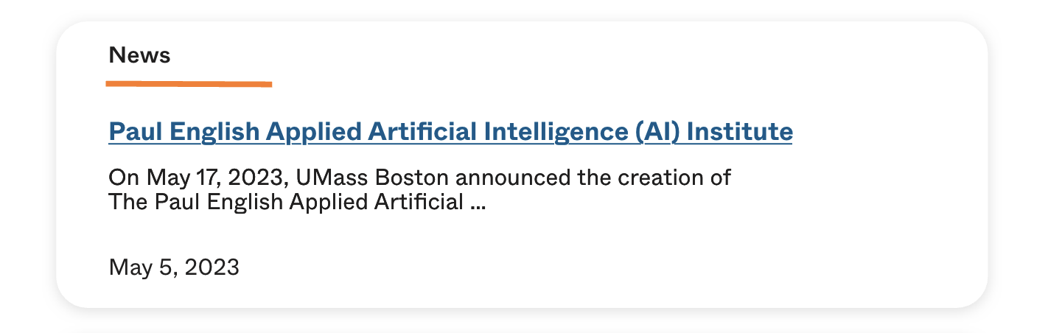

1. Page Type
2. Title Tag & URL
3. Description / Content

Note:UMass Boston

Please provide HTML for these designs.

Developer Note:

Modify title to remove " – UMass Boston"

${s.result.title?replace("– UMass Boston ","")}

#### Facets

The following facets will be used by the general (website) collection, in the order stated below:

Type: based on the collection, this will have the options of:

Website

Programs

Directory

News

Events

Similar to the following:

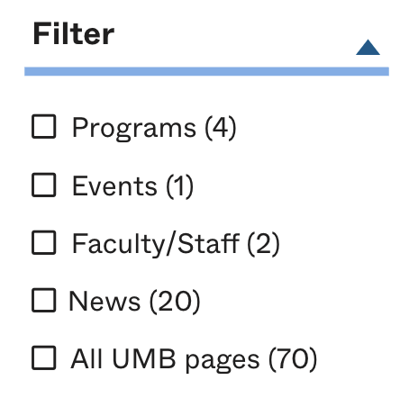

### Programs

#### MetaData

Terminalfour will update the page layouts to output the following data

PageType: Programs

ProgramImage: <t4 General Header Image />

ProgramName: <t4 type="content" name="Program Name" output="normal" modifiers="striptags,htmlentities" />

ProgramOverview: <t4 type="content" name="Program Overview" output="normal" modifiers="striptags,htmlentities" />

ProgramDegree: <t4 type="content" name="Degree Type" output="normal" display_field="value" />

ProgramFormat: <t4 type="content" name="Program Format" output="normal" display_field="value" />

ProgramDepartment: <t4 type="content" name="Department" output="normal" display_field="value" />

Each program is an <item> within the XML.

Some programs have multiple values for some elements (e.g. Campuses), and these are separated in the XML using a comma.

#### Results Format

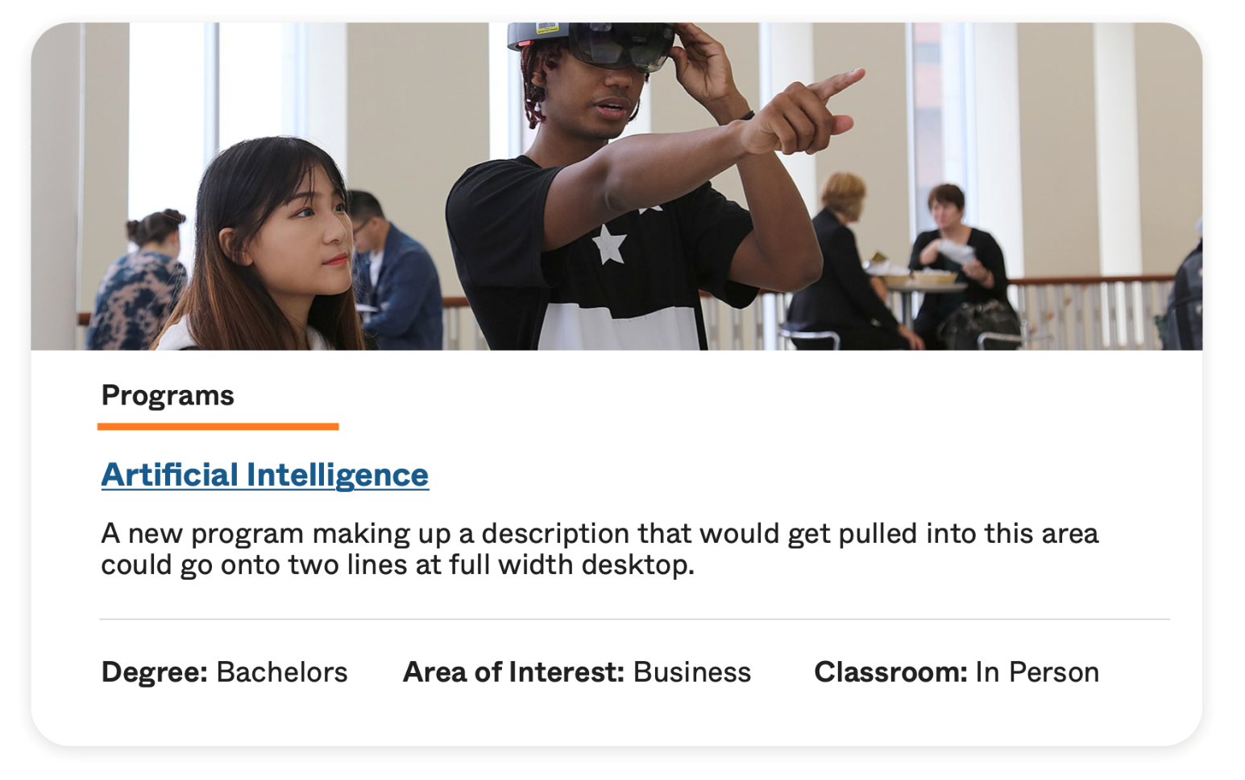

The following XML elements are used:

1. Header Image from Program Page.
2. Program name & Link
3. Program Overview
4. Program Degree
5. Program Format
6. Program Department

Styling will used the following HTML: UMass Boston will provide the HTML

### Directory

#### MetaData

Terminalfour will update the page layouts to output the following data

PageType: Directory

DirectoryName: <t4 type="content" name="First Name" output="normal" modifiers="striptags,htmlentities" /> <t4 type="content" name="Last Name" output="normal" modifiers="striptags,htmlentities" />

DirectoryDepartment: ><t4 type="content" name="Department" output="normal" display_field="value" />

#### Results Format

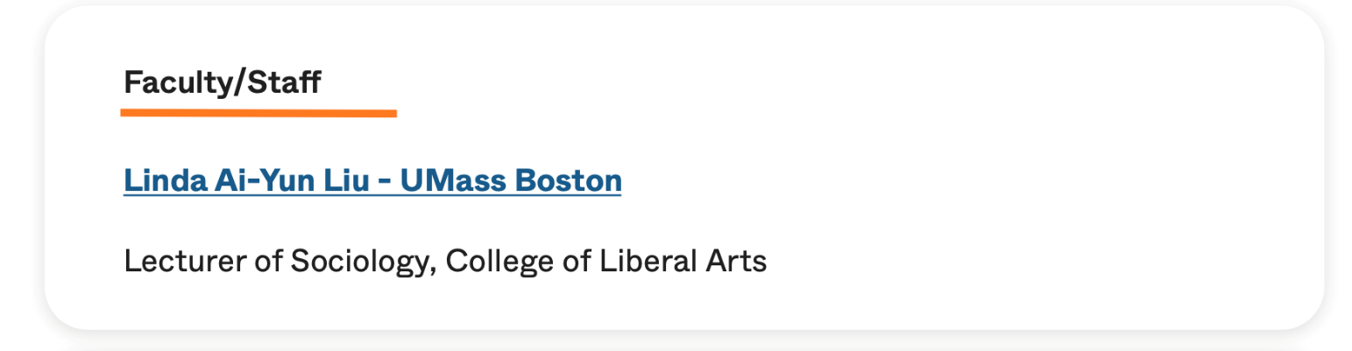

The following XML elements are used:

1. DirectoryName
2. DirectoryTitle, DirectoryDepartment

Styling will used the following HTML:[Umass](C:\\Users\\michael.morley\\AppData\\Local\\Microsoft\\Windows\\INetCache\\Content.Outlook\\FIAZDP8W\\Umass) Boston will provide HTML

### News

#### MetaData

PageType: News

NewsTitle: <t4 type="content" name="Title" output="normal" modifiers="striptags,htmlentities" />

NewsIntroduction: ><t4 type="content" name="Introduction" output="normal" modifiers="striptags,htmlentities" />

NewsAuthor: <t4 type="content" name="Degree Type" output="normal" display_field="value" />

NewsCategory: <t4 type="content" name="News Category 1" output="normal" display_field="value" />

NewsDate: <t4 type="content" name="Release Date" output="normal" />

#### Results Format

Results will be formatted similar to:

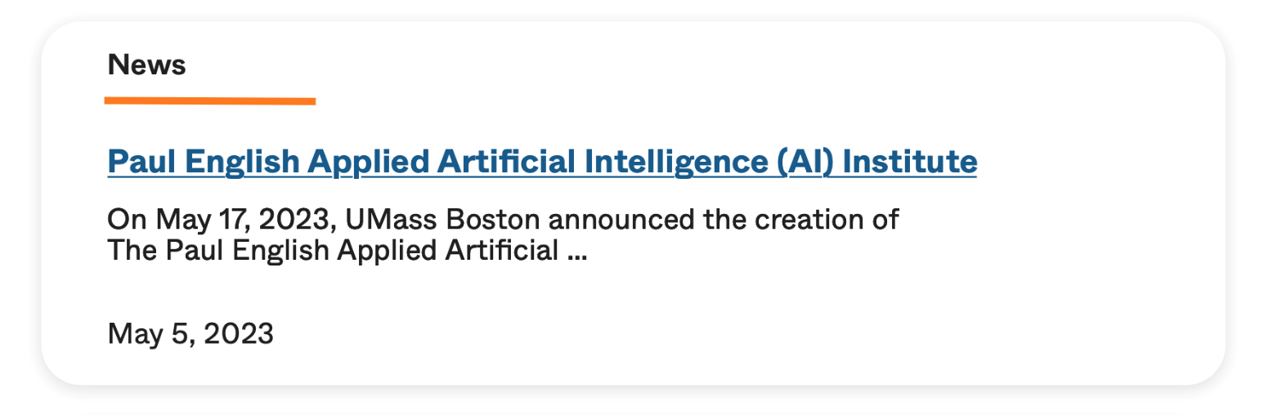

1. News Title
2. News Introduction
3. News Date

Styling will used the following HTML:UMass Boston to provide HTML

### Events

#### MetaData

PageType: Events

EventTitle: <t4 type="content" name="Title" output="normal" modifiers="striptags,htmlentities" />

EventIntroduction: ><t4 type="content" name="BriefDescription" output="normal" modifiers="striptags,htmlentities" />

EventDate: <t4 type="content" name="Degree Type" output="normal" display_field="value" />

EventTitle: <t4 type="content" name="Degree Type" output="normal" display_field="value" />

EventLocation: <t4 type="content" name="Location" output="normal" modifiers="striptags,htmlentities" />

EventCategory: <t4 type="content" name="News Category 1" output="normal" display_field="value" />

#### Results Format

Results will be formatted similar to:

1. Event Title
3. Event Date
4. Event Time
5. Event Location

Styling will used the following HTML:

UMass Boston to provide HTML

## Promoted Results

Terminalfour will implement one sample “Promoted Results External” and one sample “Promoted Results Internal” to demonstrate the functionality and test the layouts.

### Promoted Results External

External Promotions let you open up more possibilities to engage with your audience. Some other use cases include:

* Curating a path for users who land in your search thinking your site holds their answers
* Highlighting events, special courses, or conferences from partners
* Promoting internal links so they will appear separately from other promoted items
* Advertising links to commerce websites for your users looking to purchase items
* Cross-promoting content from affiliated companies or from your local community

It will be triggered by the words “Alumni” and will display

Admissions

For more information regarding admissions policies at Howard Community College, please see the Howard CC Catalog. College readiness assessment is required prior to enrollment.

<https://umb.edu/admissions>

Terminalfour will style the external promoted result to look like this:

UMass Boston will provided the HTML for the search Results.

### Promoted Results Internal

This is used to promote results internally of your site based on search term or logic.

It will be triggered by the words “wiser” and will display:

## Go-Live

As part of go-live, the following actions will be completed by Terminalfour:

Update the Search bar to link to the Production Terminalfour Search URL and not the staging URL located within Home > Site Assets > Common Header > Search Bar.

Terminalfour Search URL - <https://www.umb.edu/search/>

Update the crawl to point at the live url [www.umb.edu](http://www.umb.edu) and not a staging URL.

The actions are mentioned in the go-live checklist which will be sent to UMass Boston ahead of go-live.

## Document Sign off

This functional specification contains fully all works to be carried out by Terminalfour for UMass Boston. Any work outside of this, will be controlled via the standard change control process and will have to be agreed by both parties. Please see the Scope document for further clarification on the Change Control Process.

This specification was agreed and signed off by Brittany Terpstra, Director of Website Development from UMass Boston on behalf of their project board by email sent to Paul Grant, TerminalFour Project Manager, dated [insert date and time].